NST21022 - Practical for Network Switching and Routing
Department of Information and Communication Technology
Faculty of Technology
Labsheet :07
Reg. Number: SEU/IS/20/ICT/084
Academic Year :2020/2021
Practical No :07

Title: IPv4 VLSM (Variable Length Subnet Mask)
Aim:
• VLSM IP addressing scheme
• Configure devices with IPv4 after subnetting
Task:
• Design an IP scheme
• Subnet the IPv4 address
• Assign IP address to Network devices and verify connectivity

Use “NST21022 Labsheet 07.pka” file Activities
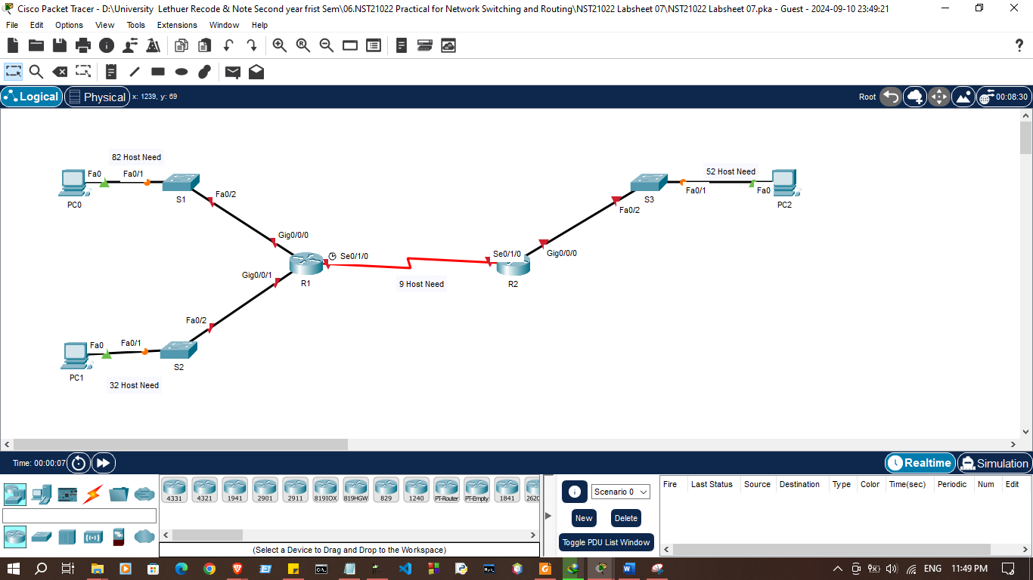

Exercise 01: Subnet the 192.168.1.0/24 network into the appropriate subnets.

- Based on the topology, how many subnets were needed?

- 4

- How many hosts need for each subnet?

- Subnet 01 –82
- Subnet 02 -32
- Subnet 03 -52
- Subnet 04 -2

- How many hosts provide by each subnet?
- Subnet 01 –128
- Subnet 02 -32
- Subnet 03 -64
- Subnet 04 -4

Exercise 02: Fill the subnet table
Subnet Numbe | Network Address
  First Usable Host Address
  Last Usable Host Address
  Broadcast Address
1 | 192.168.1.0 | 192.168.1.1 | 192.168.1.126 | 192.168.1.127
2 | 192.168.1.128 | 192.168.1.127 | 192.168.1.190 | 192.168.1.191
3 | 192.168.1.192 | 192.168.1.193 | 192.168.1.222 | 192.168.1.223
4 | 192.168.1.224 | 192.168.1.225 | 192.168.1.253 | 192.168.1.254

Exercise 03: Configure IP address according to following criteria.
1. Fill the addressing table using following guidelines:
a. Assign the first usable IP addresses in each subnet to R1 for the two LAN link and WAN link
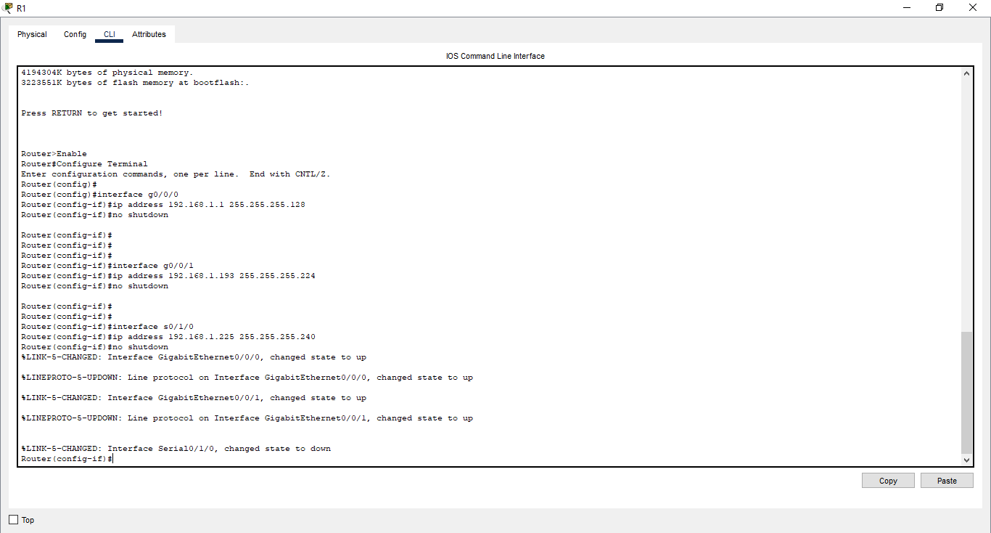

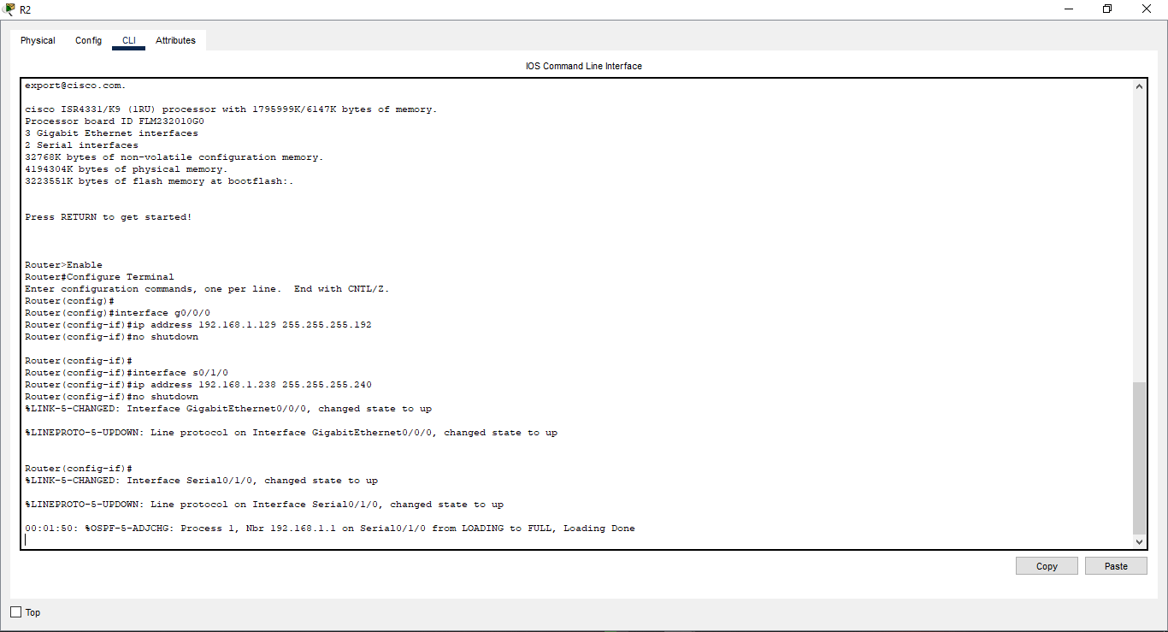
b. Assign the first usable IP addresses of the subnet to R2 for the LAN links, assign the last usable IP address for the WAN link

c. Assign the second usable IP address in the attached subnets to the switches
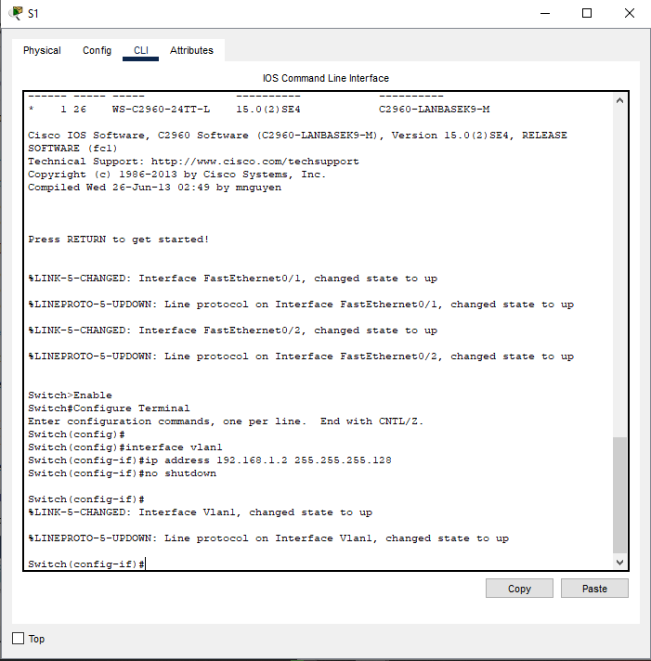

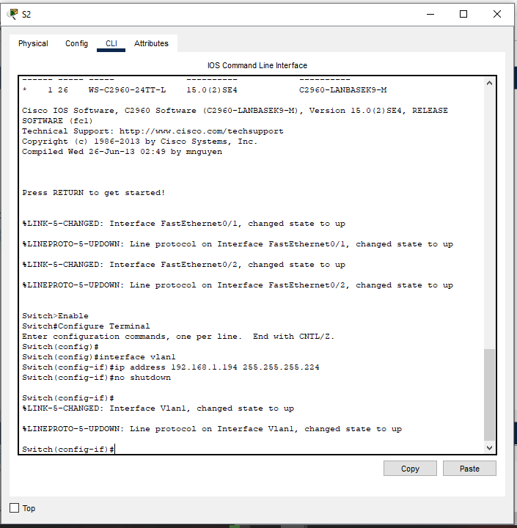

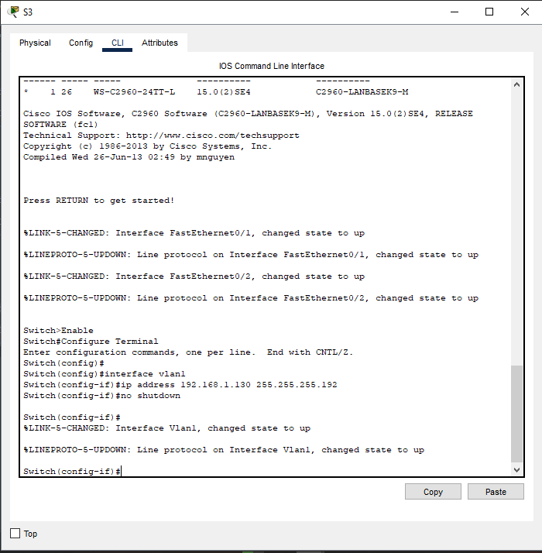

d. Assign the third usable IP address to the PCs in each subnet
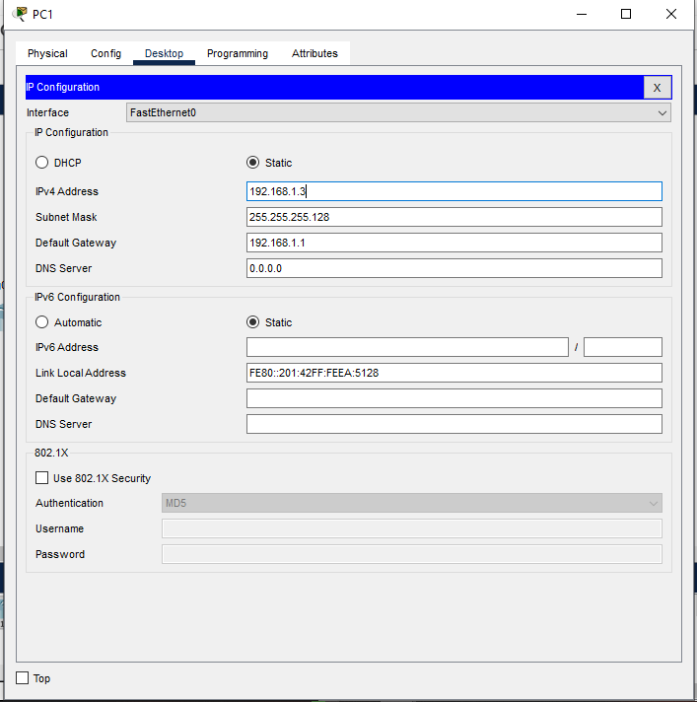

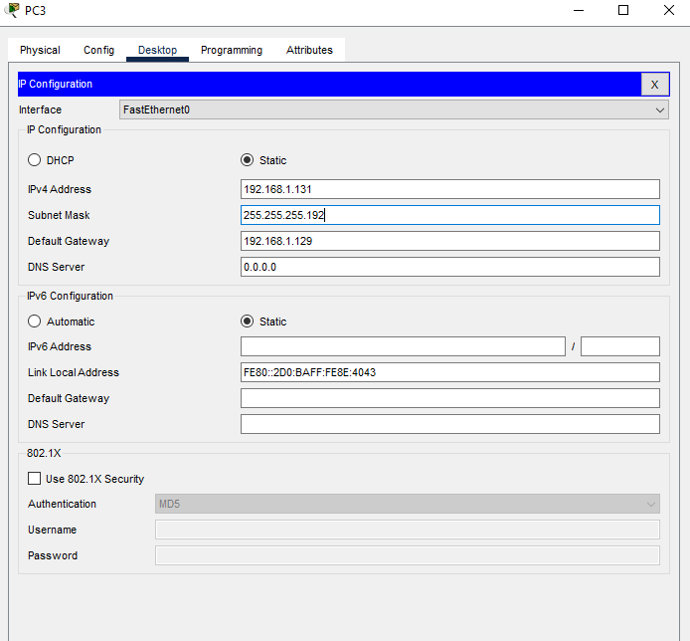

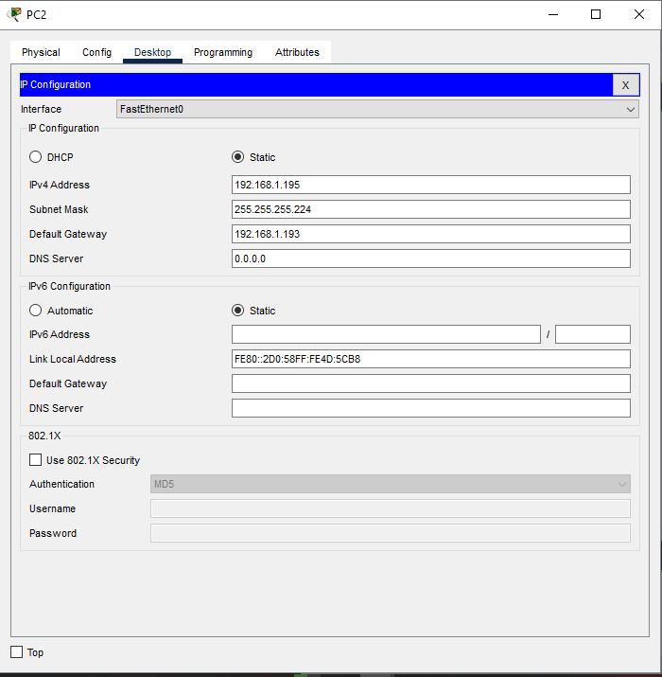

Addressing Table

Devices | Interfaces | IP Addresses | Subnet Mask | Default Gateway
R1 | G0/0/0 | 192.168.1.1 | 255.255.255.128
R1 | G0/0/1 | 192.168.1.193 | 255.255.255.224
R1 | S0/1/0 | 192.168.1.225 | 255.255.255.240
R2 | G0/0/0 | 192.168.1.129 | 255.255.255.192
R2 | S0/1/0 | 192.168.1.138 | 255.255.255.240
S1 | VLAN1 | 192.168.1.2 | 255.255.255.128
S2 | VLAN1 | 192.168.1.194 | 255.255.255.224
S2 | VLAN1 | 192.168.1.130 | 255.255.255.192
PC-1 | NIC | 192.168.1.3 | 255.255.255.128 | 192.168.1.1
PC-2 | NIC | 192.168.1.195 | 255.255.255.224 | 192.168.1.193
PC-3 | NIC | 192.168.1.131 | 255.255.255.192 | 192.168.1.129

2. Assign IP addresses to network devices and verify connectivity

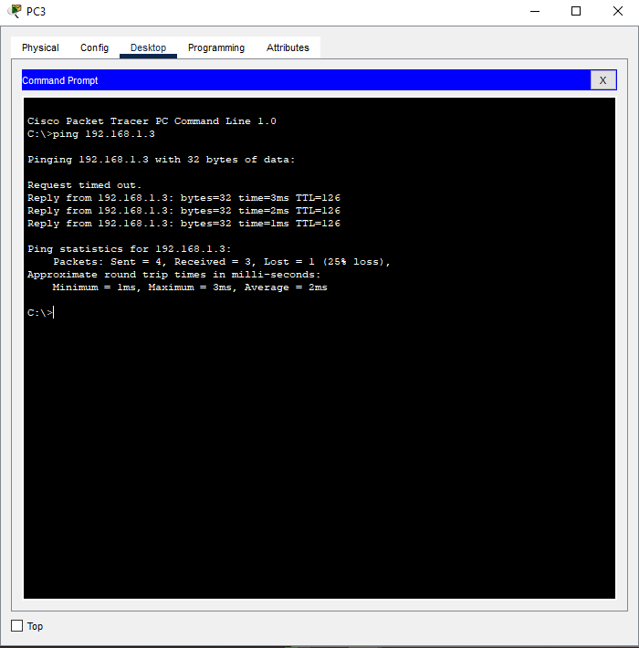

Discussion
- In this lab session, we explored the concept of Variable Length Subnet Mask (VLSM) and its application in designing efficient IP addressing schemes. The goal was to create a flexible IP addressing plan that maximizes the use of available IP addresses. We started by designing an IP scheme based on the specific requirements for different subnets, using VLSM to allocate varying subnet sizes based on the number of hosts in each network segment. After subnetting the IPv4 address using VLSM, we assigned the appropriate IP addresses to network devices, ensuring each subnet had the correct size. Finally, we verified connectivity between devices, confirming that communication within and between subnets was successful. This session provided hands-on experience in optimizing IP address allocation using VLSM.

